**Vytvorenie projetu**

1. Stiahnut JDBC opvládač pre PosgreSQL <https://jdbc.postgresql.org/download.html>

postgresql-42.3.3.jar

1. Vložiť Drag and Drop súbor postgresql-42.3.3.jar do projektu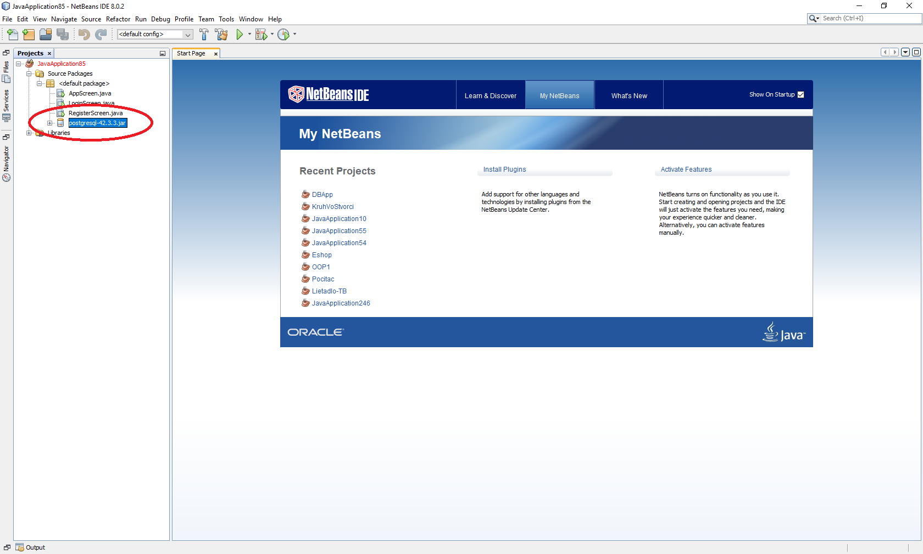
2. Nastaviť v Properties prepojenie s JAR

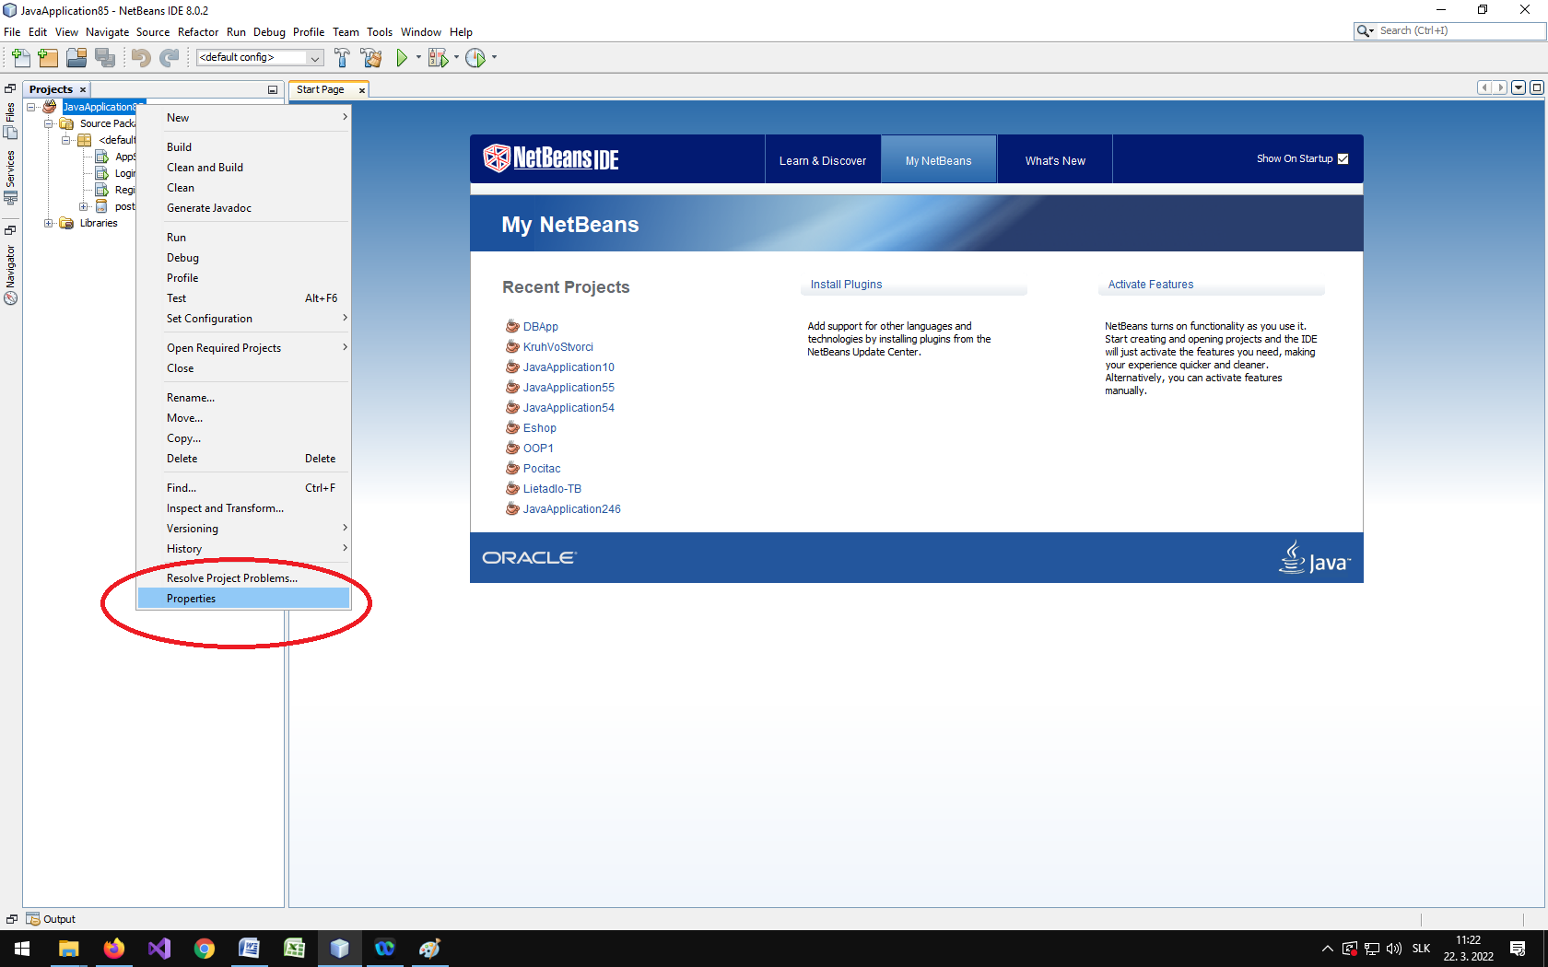

1. Vložiť JAR do projektu

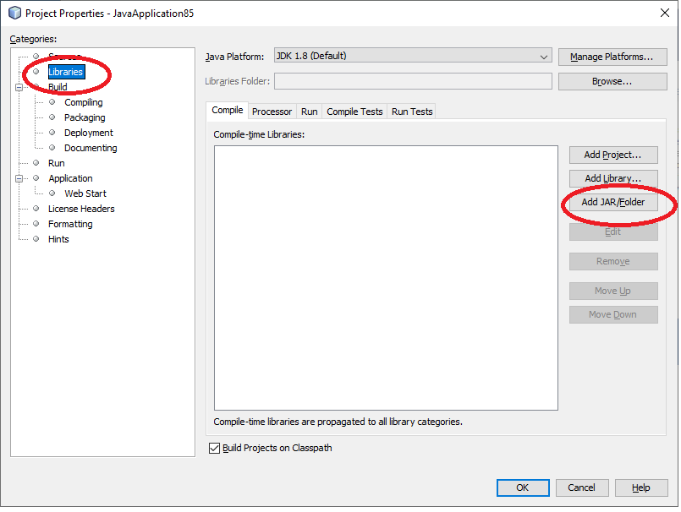

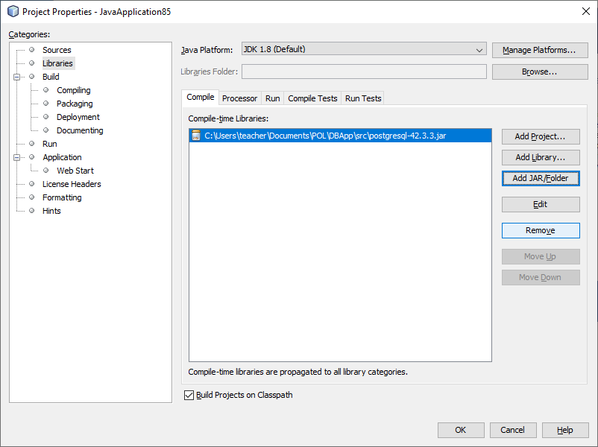

1. **Pripojenie do databázy**

try {

Connection conn = null;

String dbURL = "jdbc:postgresql://192.168.21.10:5432/projectPRO";

//String dbURL = "jdbc:postgresql://localhost/projectPRO";

String user = "ziak2";

String pass = "ziak2";

conn **= DriverManager.getConnection**(dbURL, user, pass);

if (conn != null) {

System.out.println("Connected to database");

}

} catch(SQLException ex) {

System.out.println("Unnable connect to database");

System.out.println("ERROR: "+ex .getMessage());

}

1. **Načítanie údajov y databázy**

//vyskladanie query pomocou +, pozor na ‘ ’

String query = "SELECT password FROM t_user WHERE username = **'**"+username+"**'**;";

Statement st = conn.createStatement();

ResultSet rs = st.**executeQuery**(query);

if (rs.next()) {

passwordDB = rs.getString("password");

System.out.println(passwordDB+" "+password);

} else {

System.out.println("User doesn’t exists");

}

1. **Vloženie údajov do databázy**

// údaje doplnené do query pomocou ? a set

String query2 = " insert into t_user " +

"(user_id,username,password,enabled,first_name,surname,email,first_login,last_login,status) " + " VALUES (NEXTVAL('s_user_id_seq'),?, ?, true, ?, ?, ?,now(),now(),0);";

PreparedStatement preparedStatement = conn.prepareStatement(query2);

preparedStatement.setString(1, username);

preparedStatement.setString(2, password);

preparedStatement.setString(3, firstname);

preparedStatement.setString(4, surname);

preparedStatement.setString(5, email);

System.out.println(preparedStatement);

preparedStatement.**executeUpdate**();

1. **Zmena údajov v databáze**

String SQL = "UPDATE actor "

+ "SET last_name = ? "

+ "WHERE actor_id = ?";

int affectedrows = 0;

try (Connection conn = connect();

PreparedStatement pstmt = conn.prepareStatement(SQL)) {

pstmt.setString(1, lastName);

pstmt.setInt(2, id);

affectedrows = pstmt.executeUpdate();

} catch (SQLException ex) {

System.out.println(ex.getMessage());

}

return affectedrows;

1. **Vymazanie údajov z databázy**

String query4 = "DELETE FROM t_user WHERE user_id = ?";

int affectedrows = 0;

PreparedStatement preparedStatement = conn.prepareStatement(query4);

preparedStatement.setInt(1, id);

affectedrows = preparedStatement.executeUpdate();